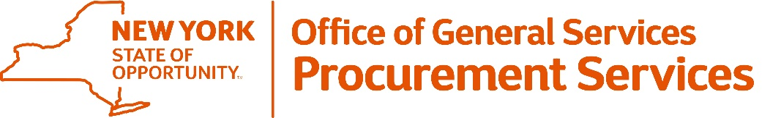
Corning Tower, Empire State Plaza, Albany, NY 12242 | https://ogs.ny.gov/procurement | customer.services@ogs.ny.gov | 518-474-6717
Periodic Recruitment Update #7
Subject: |  |  | Key Events/Dates Update
DATE: |  | September 3, 2021
IFB/RFP: |  | 22802 PR2 |  |  | BID OPENING DATE | TIME: |  | September 29, 2021 |  | 11:00AM
GROUP | TITLE: |  |  |  | 73600 - Information Technology Umbrella Contract - Manufacturer Based (Statewide)
OGS DESIGNATED CONTACTS:
 | Marc Kleinhenz; Michelle St. Jock; David Gambacorta;  Alexis Bredenko; Jordan Flores; Hannah Schmidt; Maria Lemme;  Josh Sack; Christine Swoboda, Kalee Waddingham |  |  |  |  |  |  | OGS.sm.SSTTechnology@ogs.ny.gov

The timeline for the Key Events/Dates for this Solicitation, including posting of the responses to the Second Round of Inquiries received, is being amended. OGS will provide responses to the Inquiries and an updated schedule on or about September 9, which is incorporated within the Solicitation.

All updated documents will be available on the bid solicitation page: https://ogs.ny.gov/procurement/biddocument/22802BID03.

